Project Features: Digital Output.

Program an Arduino board to simulate the traffic lights at the intersection of two streets.

R
R
Y
Y
G
G
North/South
East/West

Figure 1: Traffic Lights

To document your program, create a Word document and include all of the following sections in the document. Provide a brief description of the system and how you are designing it to operate,

A. Hardware Diagram:
Provide a hardware diagram of the components.

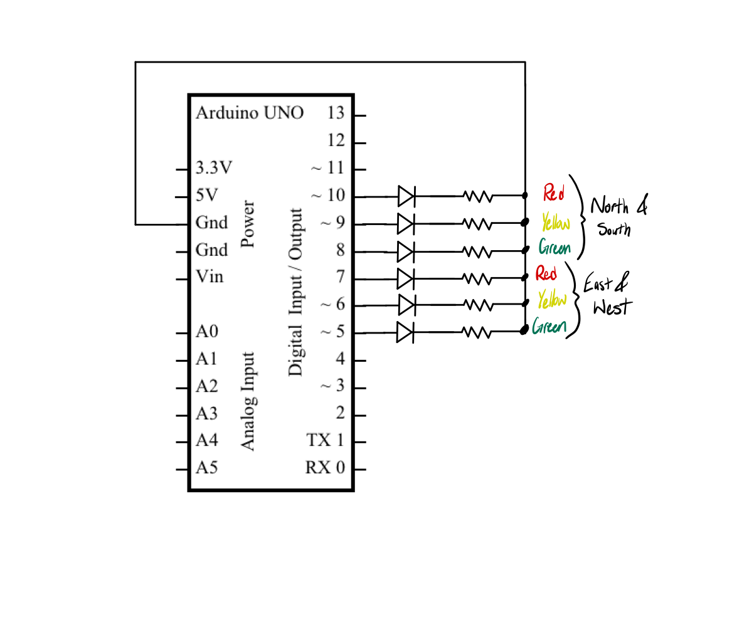
Hardware Diagram
B. Program Flowchart:
Draw a flowchart of the program using the Word graphics shapes. Describe the timing of the traffic lights in the flowchart.
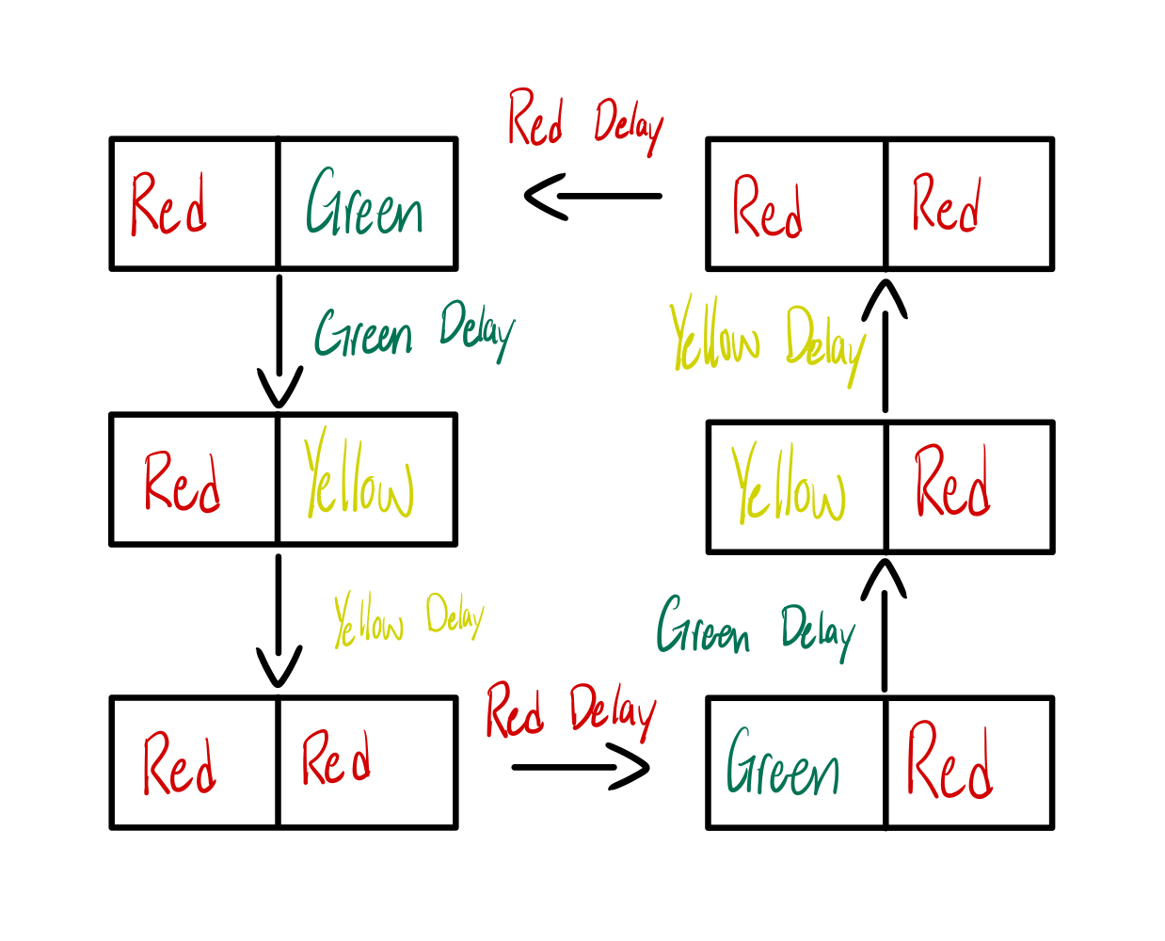
C. Arduino Source Code
// Traffic Light Simulation

const int RED_NS = 10; // North/South Red
const int YELLOW_NS = 9; // North/South Yellow
const int GREEN_NS = 8; // North/South Green
const int RED_EW = 7; // East/West Red
const int YELLOW_EW = 6; // East/West Yellow
const int GREEN_EW = 5; // East/West Green

const unsigned long GREEN_TIME = 3000; // ms
const unsigned long YELLOW_TIME = 1500; // ms
const unsigned long RED_TIME = 1200; // ms

void initializeLights() {
// Set all traffic lights as OUTPUT
for (int pin = 5; pin <= 10; pin++) {
pinMode(pin, OUTPUT);
}
}

void setLights(bool ns_red, bool ns_yellow, bool ns_green, bool ew_red, bool ew_yellow, bool ew_green) {
digitalWrite(RED_NS, ns_red);
digitalWrite(YELLOW_NS, ns_yellow);
digitalWrite(GREEN_NS, ns_green);
digitalWrite(RED_EW, ew_red);
digitalWrite(YELLOW_EW, ew_yellow);
digitalWrite(GREEN_EW, ew_green);
}

void setup() {
initializeLights();
}

void loop() {
// North/South Red, East/West Green
setLights(true, false, false, false, false, true);
delay(GREEN_TIME);

// North/South Red, East/West Yellow
setLights(true, false, false, false, true, false);
delay(YELLOW_TIME);

// Both Red before switching
setLights(true, false, false, true, false, false);
delay(RED_TIME);

// East/West Red, North/South Green
setLights(false, false, true, true, false, false);
delay(GREEN_TIME);

// East/West Red, North/South Yellow
setLights(false, true, false, true, false, false);
delay(YELLOW_TIME);

// Both Red before switching back
setLights(true, false, false, true, false, false);
delay(RED_TIME);
}
D. Demonstration Video
Record and upload a video demonstrating the operation of the circuit. (DONE)
Save the document as a PDF file and submit the PDF document to Blackboard.

